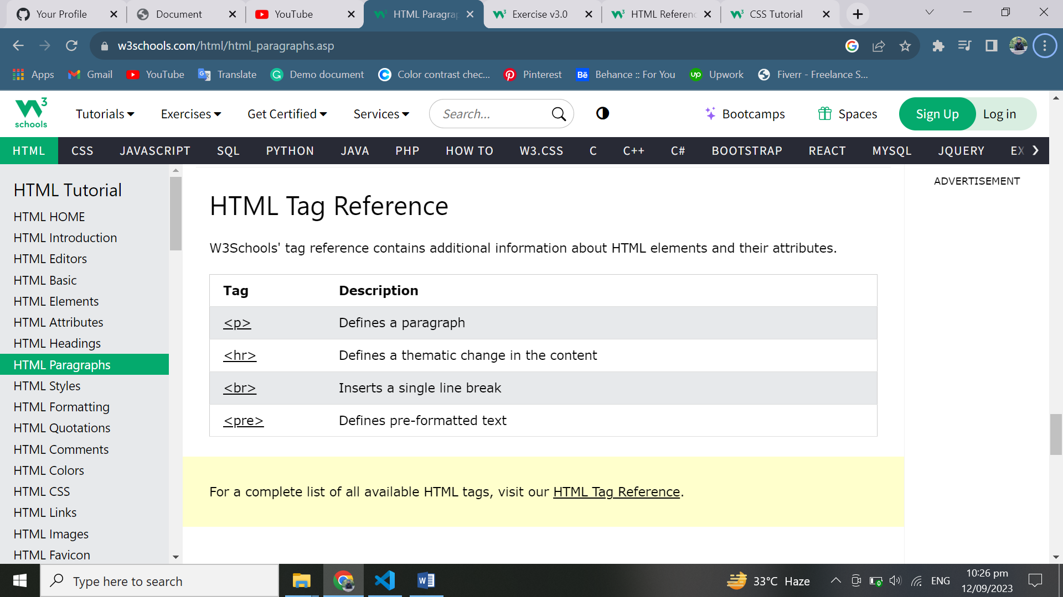

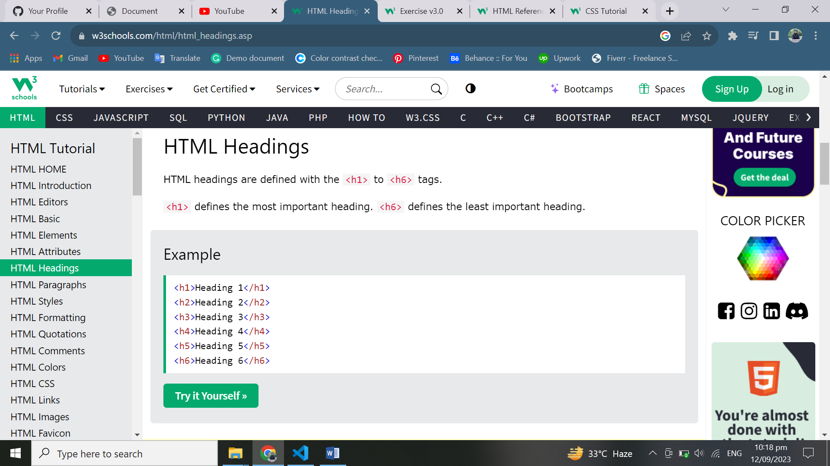

|  |  |
| --- | --- |
| **Tag** | **Description** |
| [<html>](https://www.w3schools.com/tags/tag_html.asp) | Defines the root of an HTML document |
| [<body>](https://www.w3schools.com/tags/tag_body.asp) | Defines the document's body |
| [<h1> to <h6>](https://www.w3schools.com/tags/tag_hn.asp) | Defines HTML headings |

